Shopping cart User Manual

Shopping cart features

This document describes Shopping cart features. This document is not final and is subjected to revisions and updates accordingly with the users requirements and the change requests. Any questions regarding this document and the availability of the current version should be forwarded to Dan [dan.ecom123@hotmail.co.uk]

If you have any queries regarding any of our services, please contact us and our friendly team will be happy to help you.
Email Address:
sales@e-commerce123.com
Telephone:
0845 123 56 26

Fax:
01702 382812

Address:
E-Commerce 123
36 Towerfield Road
Shoeburyness
Essex
SS3 9QT

Table of Contents

1. About This Manual…. ……..4
a. Login Page 6
b. Home Page 7
2. Content Management. 7
a. Manage CMS. 8
b. Manage Copyright. 9
3. Clients. 9
a. Manage Client. 10
b. Search Client. 10
4. Statistics. 11
a. Order Statistics. 12
5. Categories. 12
a. Add Category. 13
b. Manage Category. 13
6. Products. 14
a. Add Product. 15
b. Search Product. 15
c. Featured Product. 16
d. Best Selling Product. 16
e. Add Stock. 17
7. Order Management. 18
8. Discounts. 19
a. Add Discount. 20
b. Search Discount. 21
9. Taxation. 22
a. Define Tax. 23
b. Add Tax. 23
c. Manage Tax. 24
d. View Product Tax. 24
10. Shipping. 25
a. Add Shipping Company. 26
b. Manage Shipping Companies. 26
c. Assign Delivery Country. 26
d. Manage Delivery Countries. 27
e. Define Shipping Rates. 27
f. Manage Shipping Rates. 27
11. AWStats. 25
a. AWStats. 26
10. Attributes. 25
a. Attributes. 26

1. About This Manual

This manual explains how the End Users will use the Shopping cart System.

However this manual assumes that the user is comfortable using a computer and is familiar with normal windows functionalities e.g. files, menus, browsing, emailing etc. If you are unfamiliar with using a computer, a tutorial course is recommended before you start using this system .
a.Login Page

Title | Login Page
Description | admin must be login with a valid username and password.
Prerequisites | None
Flow | Page can be accessed from <website_url>/admin/index.php  - Enter Login & Password.  - Click Login button.  - On successful login user will be redirected to Home Page.
Actor | User
SCREEN LAYOUTS:

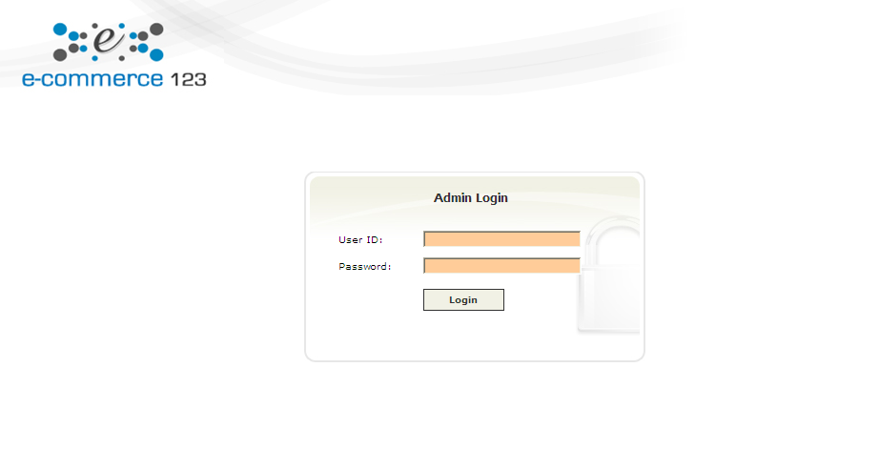
Figure 1

b.Home Page

Title | Home Page
Description | Home page of application shows module access as defined in user roles.
Prerequisites | - User must be logged in  - User has rights to access modules as defined in their roles
Flow | Click appropriate module to perform specific functionality.
Actor | User
SCREEN LAYOUTS:

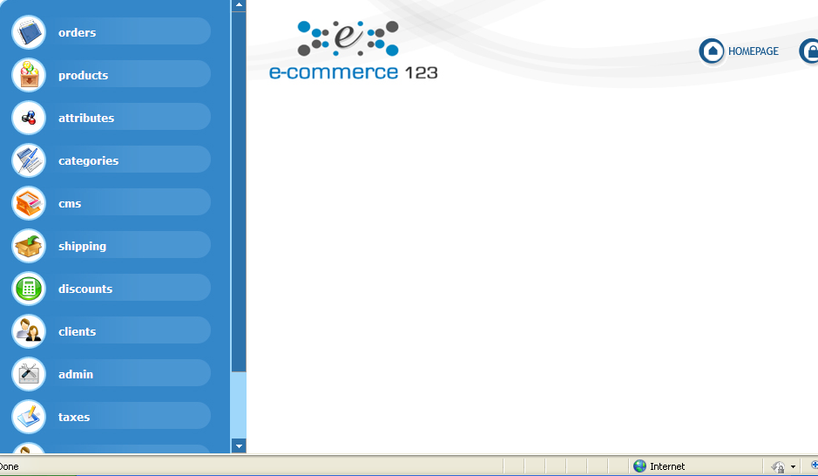
Figure 2

2. Content Management System (cms)

Title | cms
Description | Contain the Sub modules  a. Manage CMS.  In this section site admin can add new page and also can update the existing page.  Manage Copyright.  In this section site admin can update its copyright data and also its text color in footer.
SCREEN LAYOUTS of Manage CMS.:
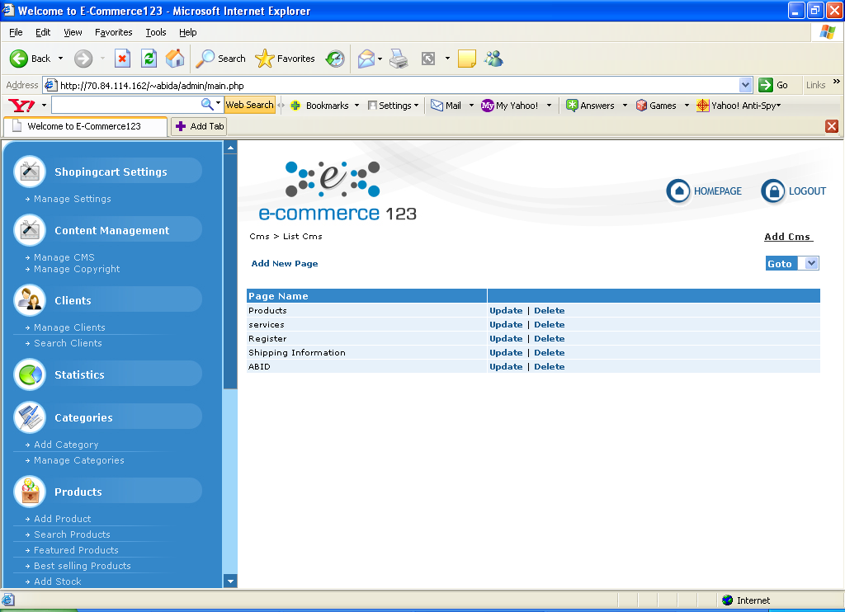

Figure 3

SCREEN LAYOUTS of Manage Copyright.

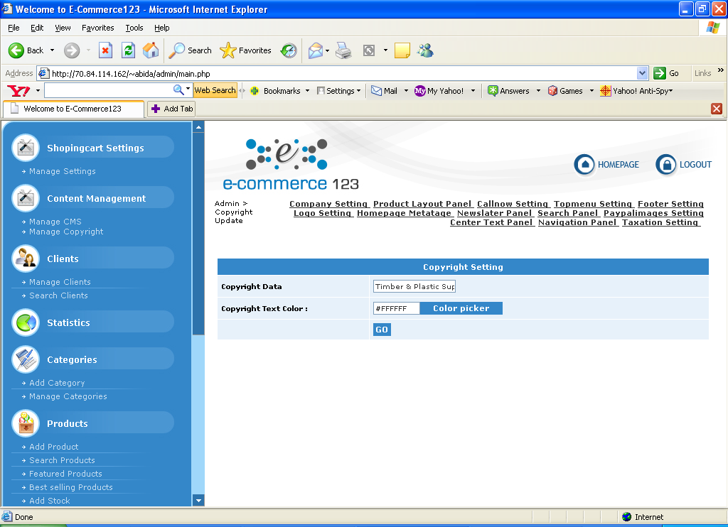

Actor | User

3.Clients

Title | Clients
Description | Contain the Sub modules  a. Manage Client.  In this section site admin can view the list of clients and also can edit the specific client information, view client information, Delete Client, and also Update client status with Block or Unblock. Blocked Client cant login and cant do shopping on the web.  b. Search Client.  In this section site admin can search client by its status, forename, surname, email address, client’s company name and its date of registration.
SCREEN LAYOUTS of Manage Client.:
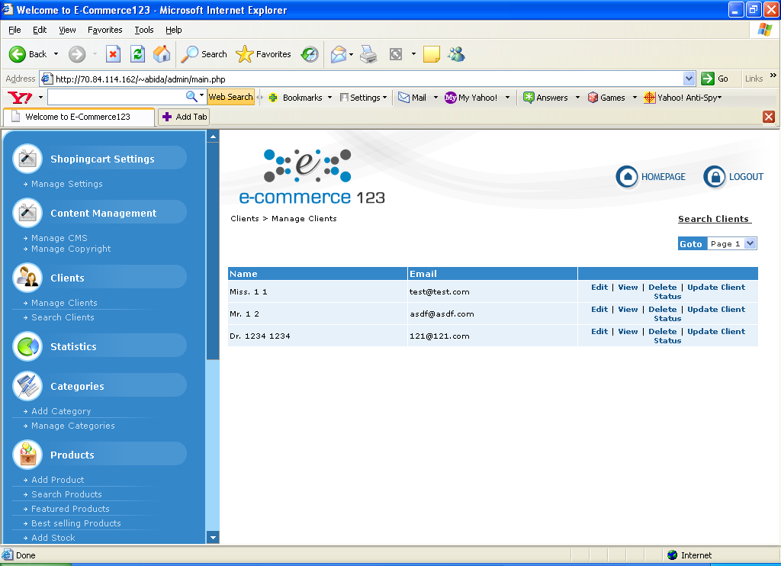

Figure 4

SCREEN LAYOUTS of Search Client.

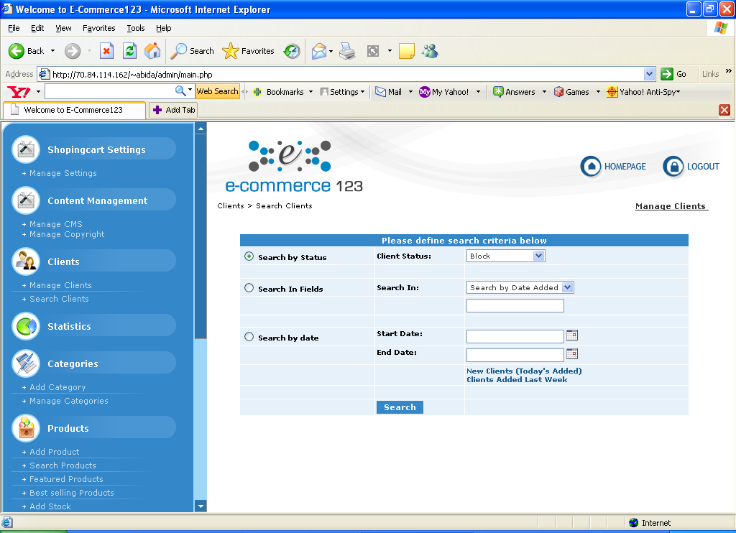

Actor | User

4.Statistics

Title | Statistics
Description | Contain the Sub modules  . 1. Show Statistics.  In this section site admin can view the detailed information (number of orders, amount) of cancelled, pending or processed orders in current day or monthly basis.  Site admin can also view the maximum product sold and viewed
SCREEN LAYOUTS of Order Statistics.
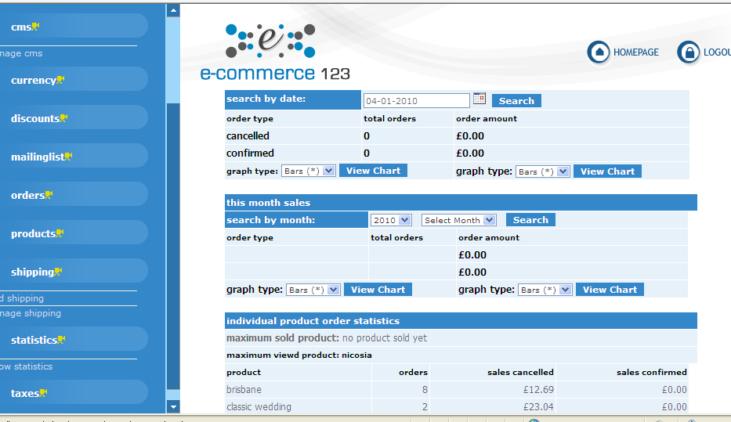

Figure 5

Actor | User

5.Categories.

Title | Categories.
Description | Contain the Sub modules  a. Add Category.  Here site admin can add new category information (name, description, image meta tage, meta description and its parent category or make it parent).  b. Manage Category.  In this section site admin can view the list of categories, edit the specific category information and Delete empty category.
SCREEN LAYOUTS of Add Category..:
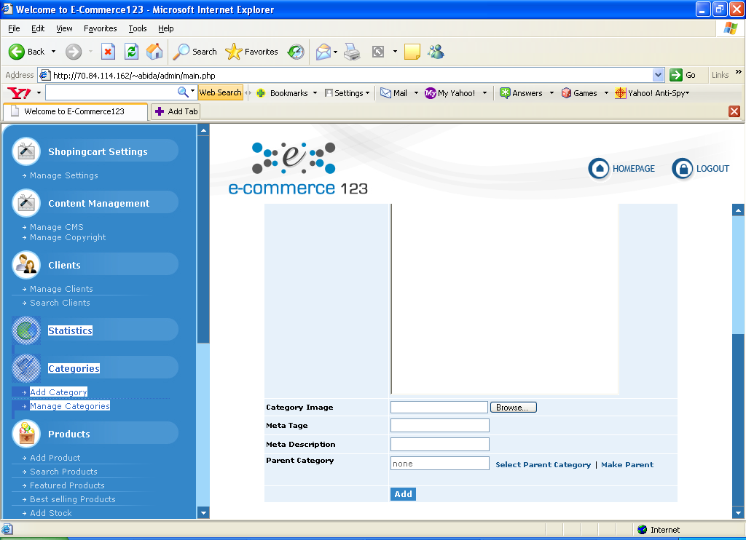

Figure 6

SCREEN LAYOUTS of Manage Category

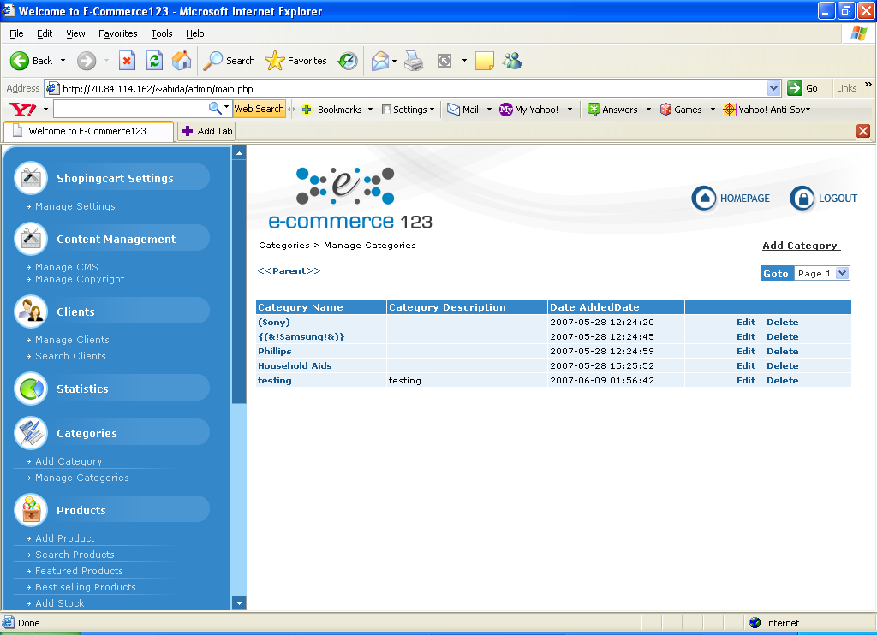

Actor | User

6.Products

Title | Products
Description | Contain the Sub modules  a. Add Product.  In this section site admin can add product on behalf of category which means which product belongs to which category by entering the required information related to product.  i-e Product Name, Code, Small Description, Detailed Description, Stock (Should be non negative no.), Weight (Should not be null), Image, Taxation (optional), Price and selected category  and attributes optional.  b.Search Product.  In this section site admin can search product by its name, code, stock, category.  c.Featured Product.  In this section admin can add product as featured product by giving its order.  d.Best Selling Product.  In this section admin can add product as best selling product.  e.Add Stock.  In this section admin can add stock of selected product.
SCREEN LAYOUTS of Add Product.:

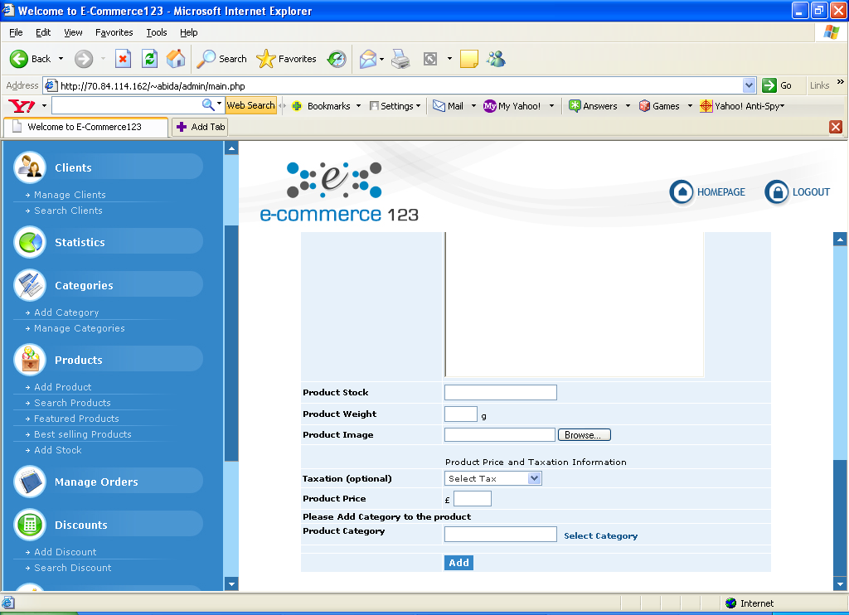

Figure 7

SCREEN LAYOUTS of Search Product.

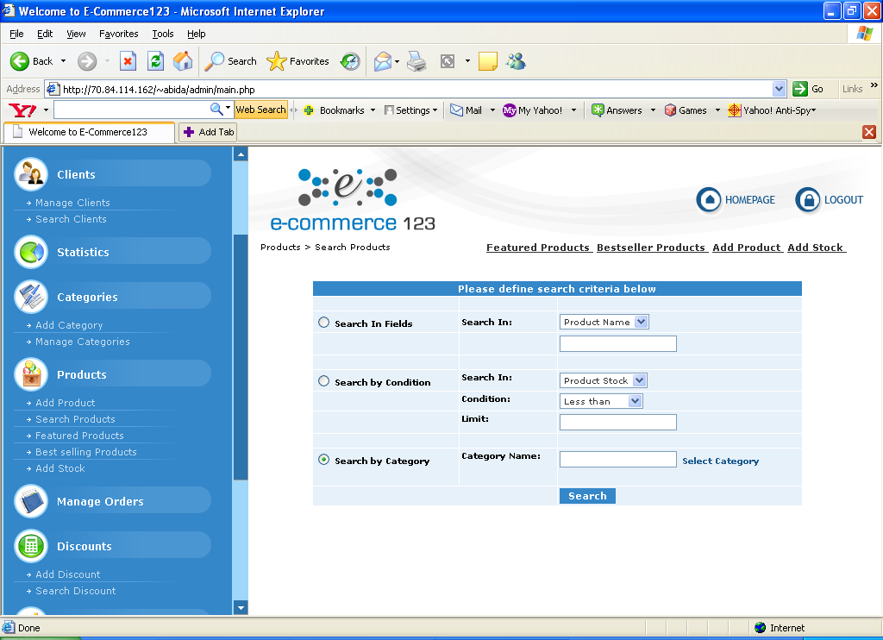

SCREEN LAYOUTS of Featured Product

Figure 8

SCREEN LAYOUTS Best Selling Product.

SCREEN LAYOUTS Add Stock.
.

SCREEN LAYOUTS of Featured Product
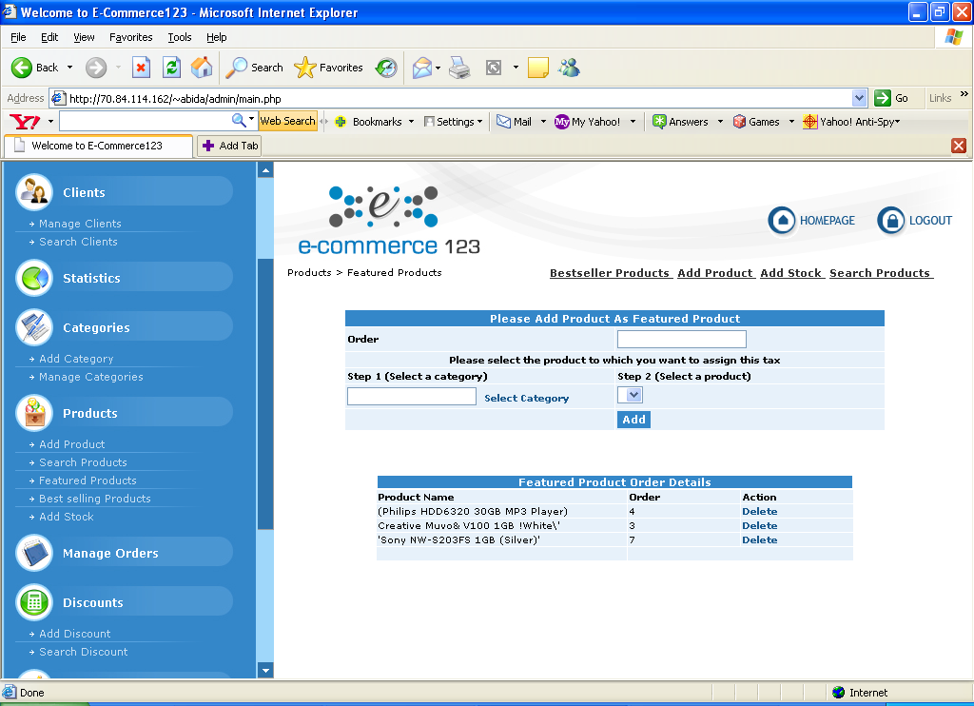

Figure 9

SCREEN LAYOUTS of Best Selling Product.

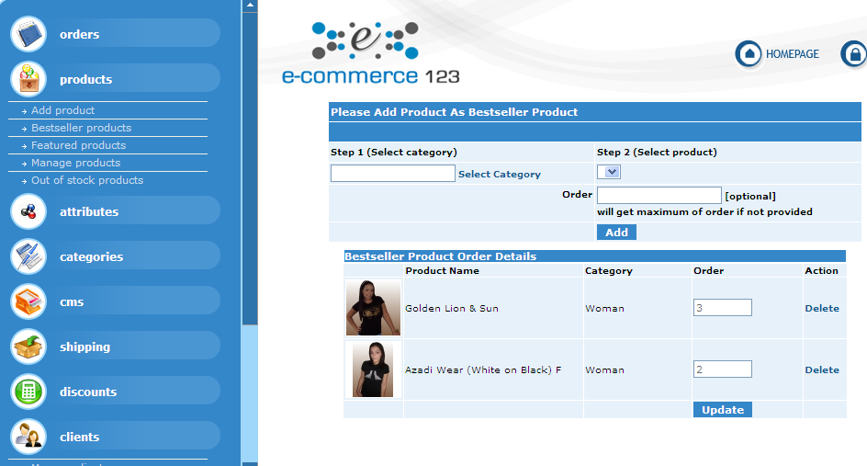

Actor | User

7. Order Management.

Title | Order Management.
Description | Order Management.  In this section site admin can view order information by selecting search criteria.  Order search can be made by the following options  - Order Status (Cancelled / Processed).  - Invoice Number.  - By Date.  - By Price Condition.

SCREEN LAYOUTS of Order Management:
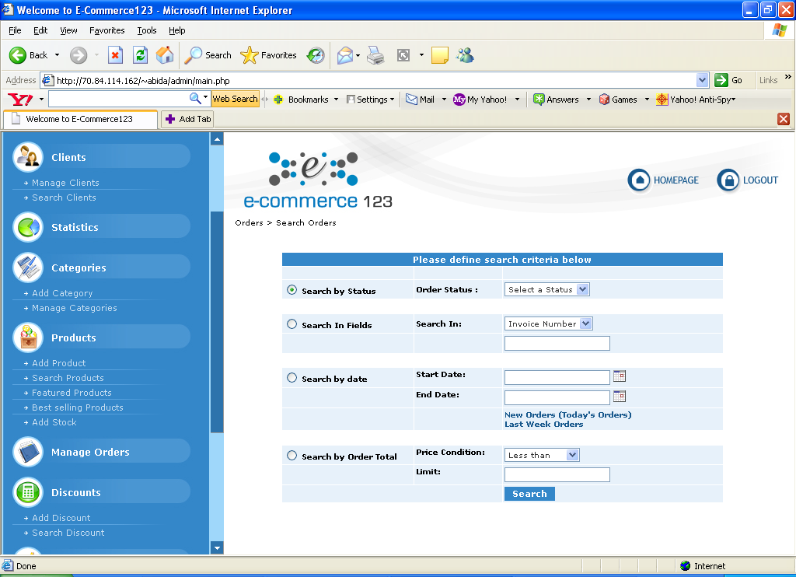

Actor | User

8. Discounts

Title | Discounts
Description | Contain the Sub modules  a. Add Discount.  In this section site admin can add discount to the selected product or on all products by defining discount name and value in Percentage (Value should be less then 100%). Or Flat Rate.  b. Search Discount.  In this section site admin can search discount by the following options.  - Show All Discounts.  - Search In fields (Discount Code, Value and ID).  - Search By Condition (Discount value < >).  - Search By Discount Status (Used).  - Search By Product.
SCREEN LAYOUTS of Add Discount.
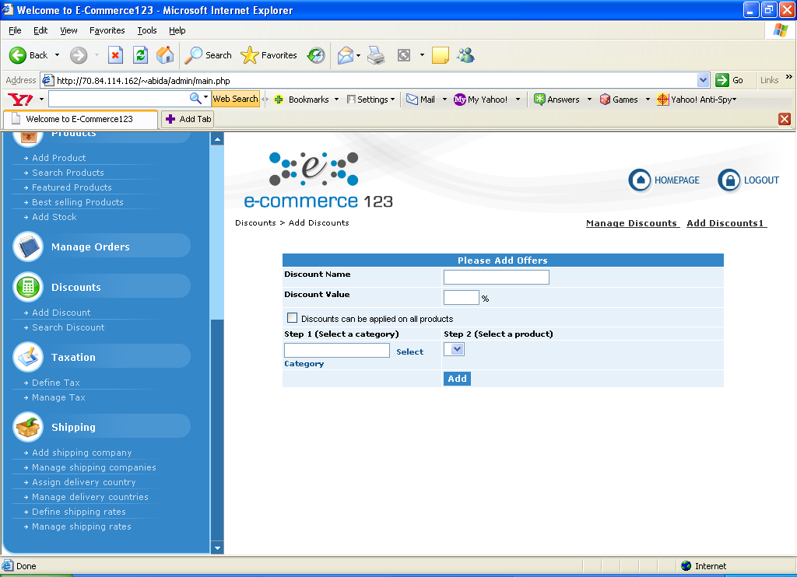

Figure 10

SCREEN LAYOUTS of Search Discount.

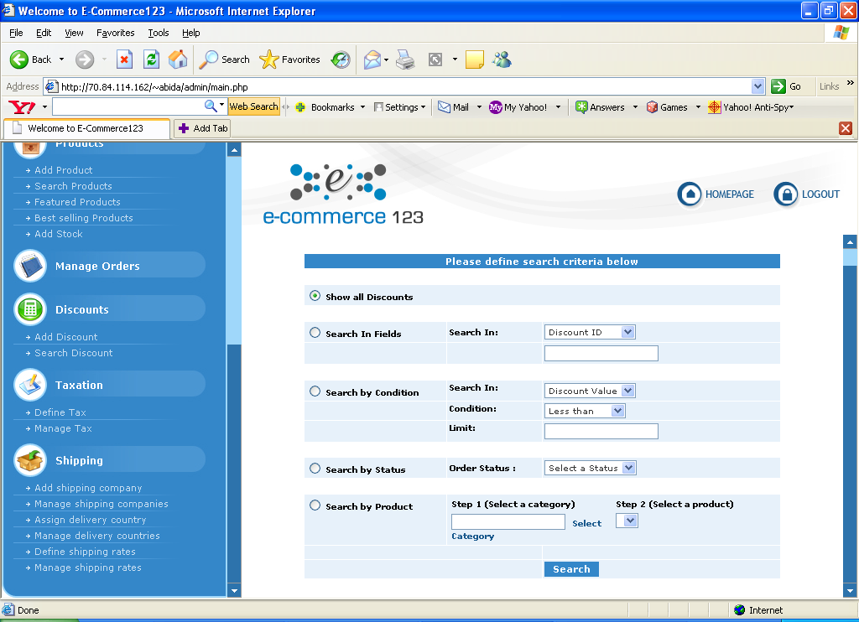

Actor | User

9.Taxation.

Title | Taxation
Description | Contain the Sub modules  a. Define Tax.  Site admin can define tax by defining Tax Name, Tax Type (Percentage / Flat Rate), and Tax value.  b. Add Tax.  Site admin can add tax to product by defining tax name, type and value after selecting the specific product.  c. Manage Tax.  Site admin can view the list of taxes by their names and values. Site admin can also edit and delete the listed taxes.  d. View Product Tax.  Site admin can view the tax applied on specific product by selecting the specific product.
SCREEN LAYOUTS of Define Tax..:
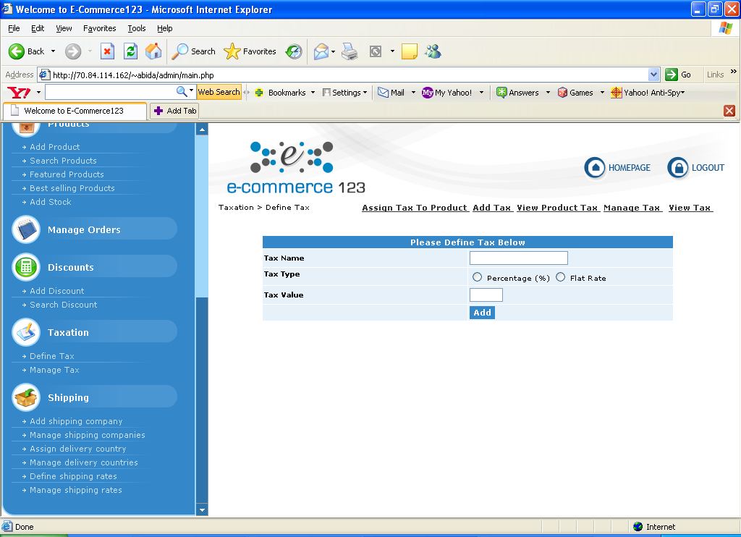

Figure 11

SCREEN LAYOUTS of Add Tax.

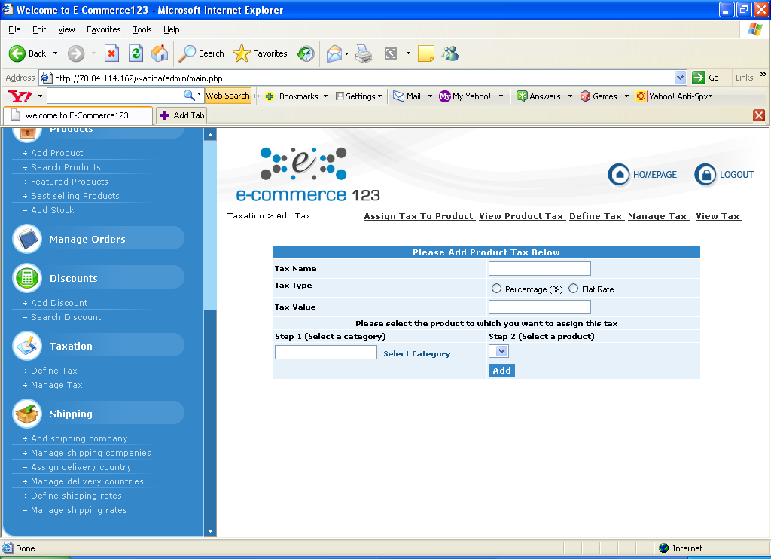

SCREEN LAYOUTS of Manage TAX.:
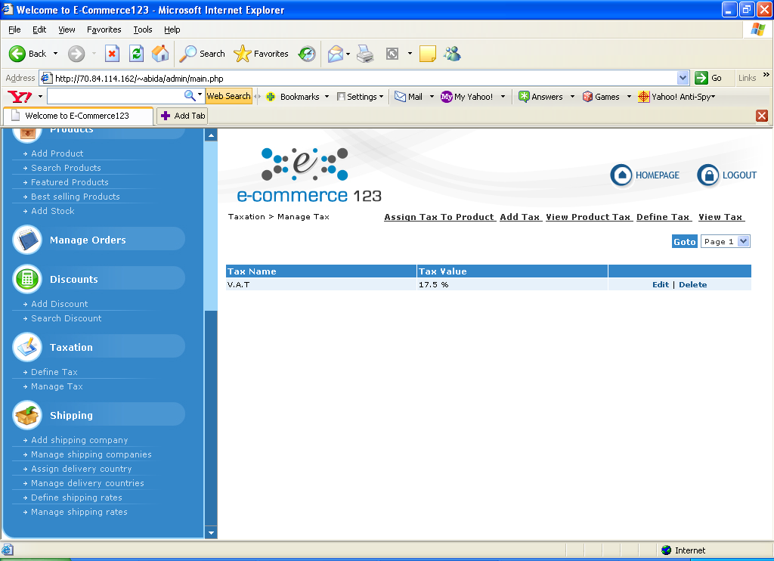

Figure 12

SCREEN LAYOUTS of View Product Tax..

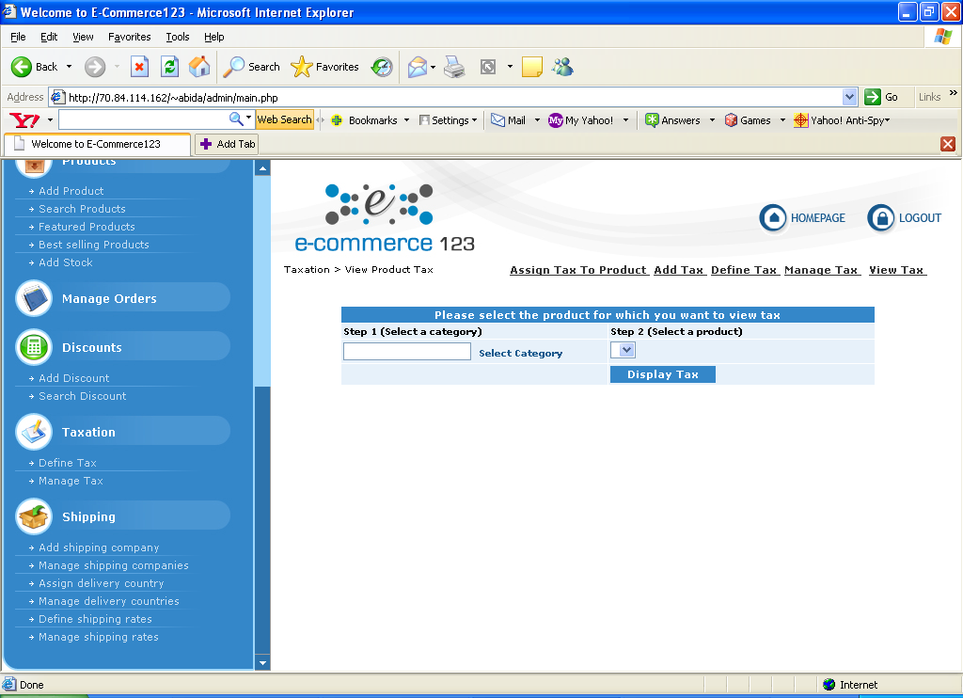

Actor | User

10 .Shipping

Title | Shipping
Description | Contain the Sub modules  a. Add Shipping Company.  Here site admin can add new shipping company name, Define Shippping Rates.  Manage Shipping Companies.  Here site admin can edit & delete the companies added.further can views shipping rates as well.
SCREEN LAYOUTS of Add Shipping Company..:
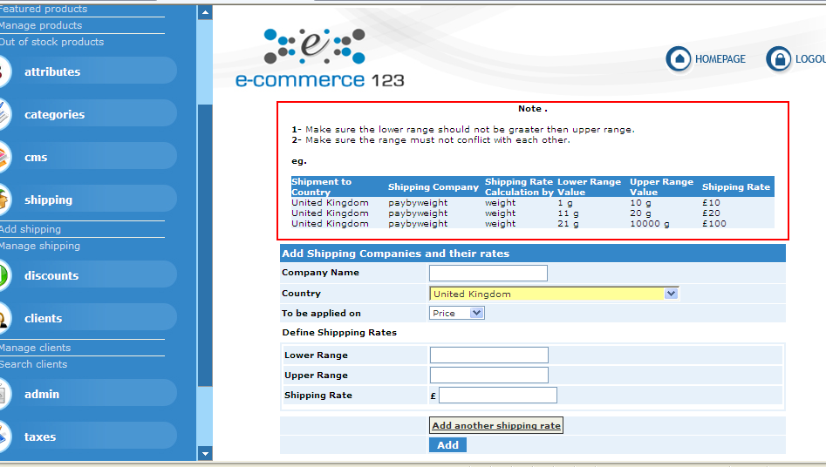

Figure 13

SCREEN LAYOUTS of Shipping Company :

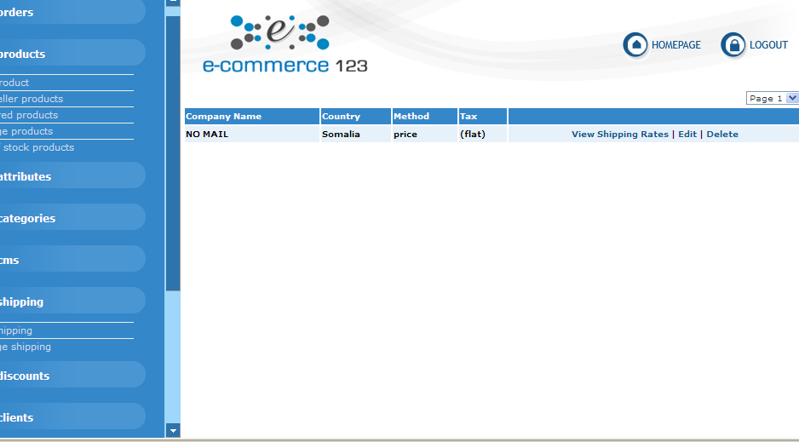

Actor | User

11. AWStats

Title | Contain the Sub modules
Description | Contain the modules  AWstats.  We have installed awstats in our shopping cart as soon  As the admin user click on the specific module we have setting up the login and password for the security enhancement .  We have setting up the awstats access equivalent to admin access .  .  AWStats is basically a powerful log analyzer which creates advanced web, ftp, mail and streaming server statistics reports based on the rich data contained in server logs. Data is graphically presented in easy to read web pages.
SCREEN LAYOUTS of AWstats
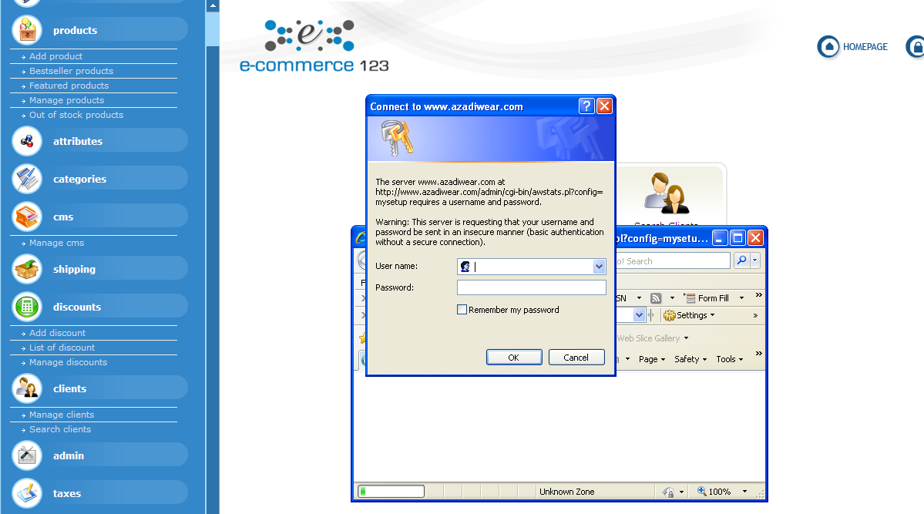

Figure 14

SCREEN LAYOUTS of Awstats:

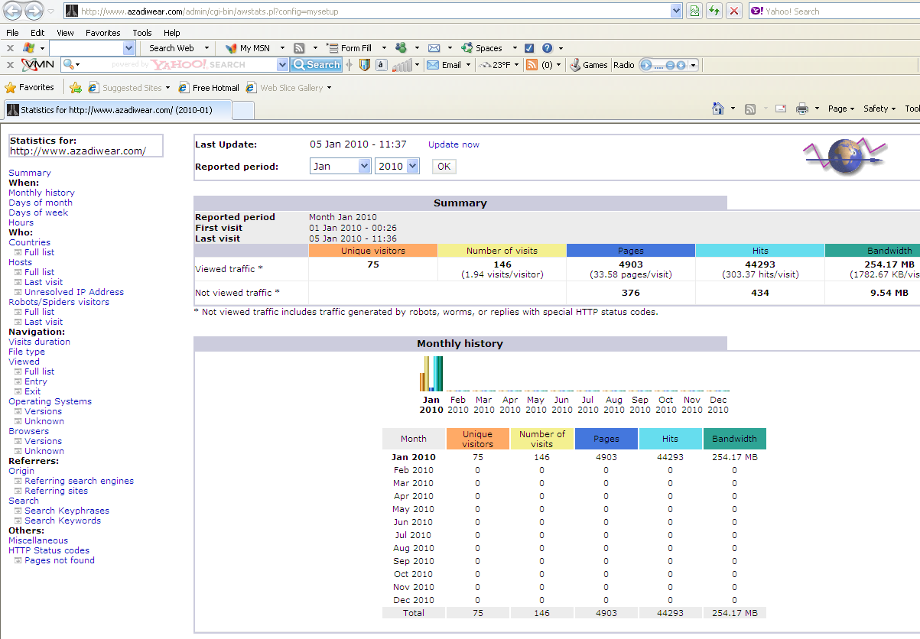

Actor | User

Title | Contain the Sub modules
Description | Contain the modules  Attributes.  In this module admin user can setup attribute value on behalf of each product there can be one or more attribute values.  If attribute prices exist our shopping running on the base of that attribute values .otherwise it will run on the normal product price values .  Further it facilitate the admin user to enter one or more attribute values.
SCREEN LAYOUTS of Attributes
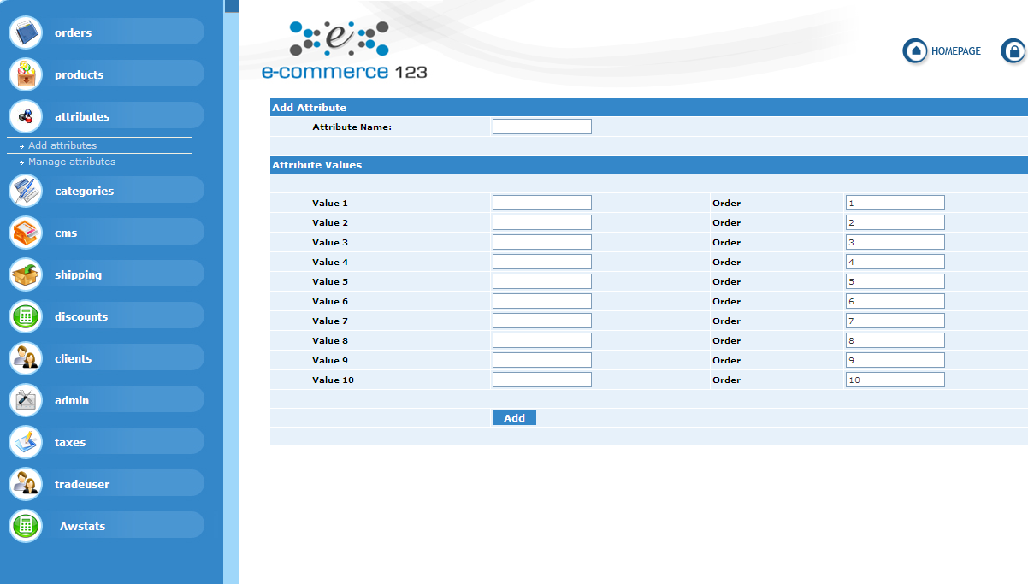

Figure 15

SCREEN LAYOUTS of Attributes Management.
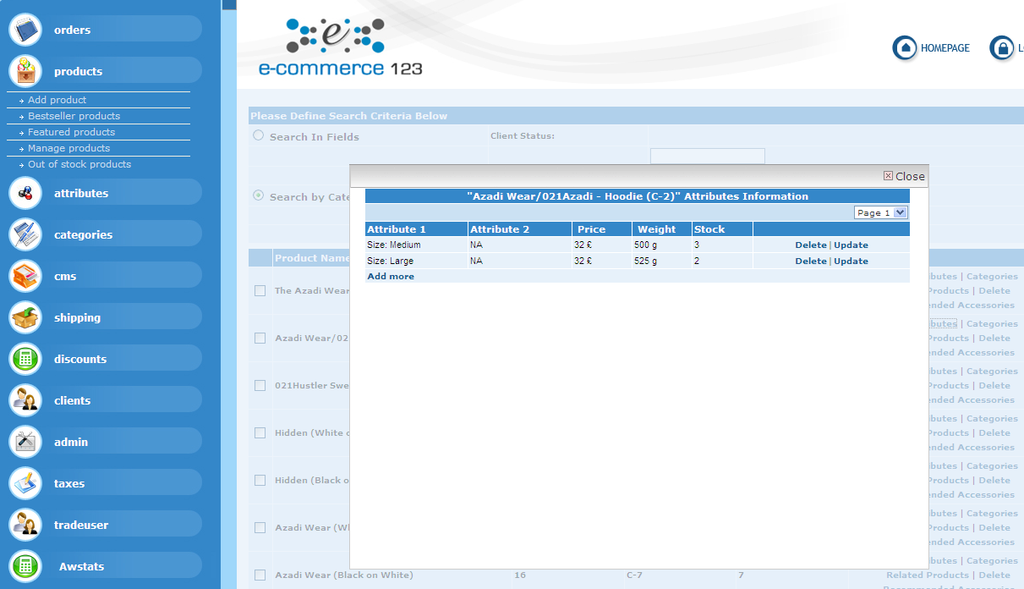

Actor | User

