Product Module

Unlimited products can be added in each and every category. Products can be mapped to more than one category, sub category, sub-sub-categories, etc. Here is how the product page looks on client side.

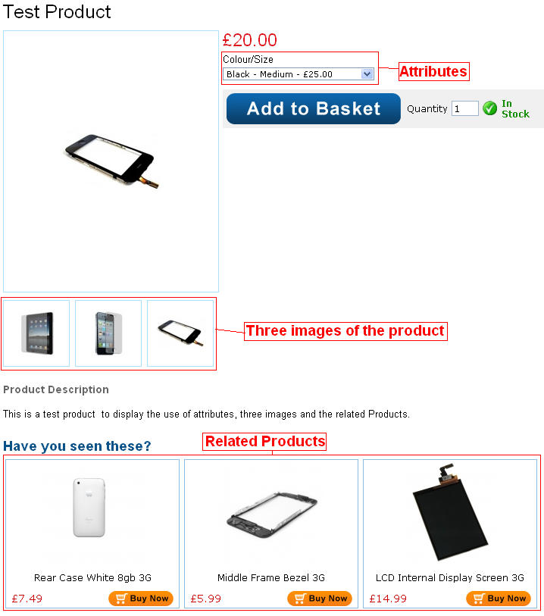

1. Add Products:
To add products click the Product button form the menu on left section of the admin area. It will expand the menu, click on Add Product. The following form will appear in the main area.

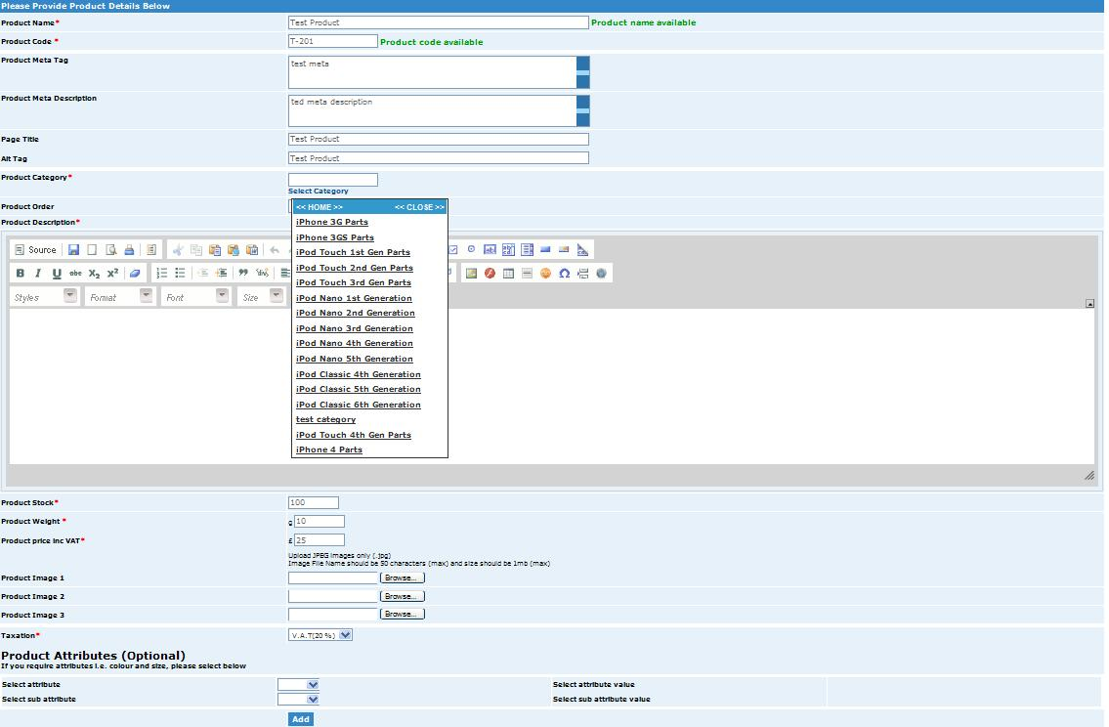

Product Name - Enter your product name in this field. The product name is displayed to the user in the product list, product detail and cart screens in the shopping cart. As you enter the product name a message will appear in front if the name is available in green or in red color if name already exists.
Product Code – Enter your product code or model number in this field. The product code is typically a unique number that identifies your product for inventory purposes.
Meta Tag – The keywords entered in this field will be dynamically added in the URL of the product listing page when a user clicks on a product from the browse page. Enter keywords that are relevant and targeted towards your product. Targeted keywords in the URL help your SEO rankings. Read the admin module for detailed info about SEO and importance of Meta tag keyword and description.

Product Category – The product category field is used to select category or subcategories to which you want to add the product. Click on the Select Category link, below this field a menu will appear. Select the desired category or sub category from the drop down menu.
Product Order - The product order field controls the order in which the products are displayed in the product catalog. Enter a number from 1 to 999. The products will be sorted in ascending order by the product order field.
Product Description – Enter a detailed product description using the rich text editor. The editor fully supports HTML. This product description will appear in the product details page. The images insertion, text formatting and a lot of other options are available in the editor.

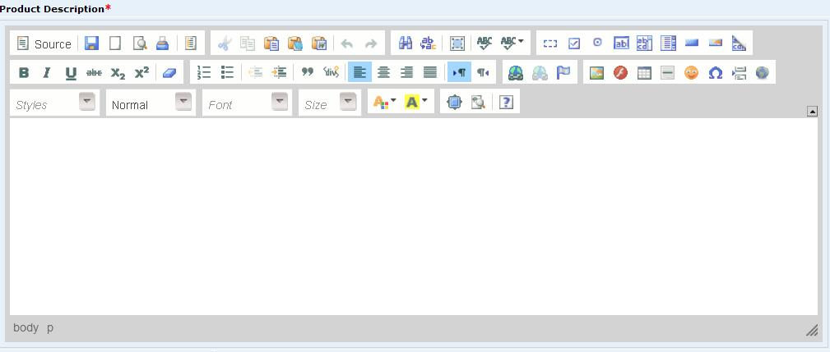

For instructions on how to use the different features of the text editor please visit: http://docs.cksource.com/FCKeditor_2.x/Users_Guide

Product Stock – The Product Stock field is used to manage available inventory for the product. Enter the current available product quantity you have in your inventory. Every time a user purchases any unit of that product, the quantity on hand is decremented by the number of units purchased. If a product has a quantity on hand equal to zero or if the customer tries to purchase a quantity of product that exceeds the available on hand units then the cart will display an out of stock message on the Product Details screen and not allow the user to proceed to checkout.
Product Weight – Enter your product weight here. The weight field can be only be numeric value. The weight entered here is used in calculating the shipping.
Product Price Inc VAT – The product Price is the cost you want to charge for your product. The product Price including the VAT the price is shown in red on the product details and cart screens. The VAT is then calculated on the cart screen and is shown in whole on the invoice to the customers.
Product Images – The product photo uploaded here will be displayed to the user in the product details page. Additionally, the cart will automatically generate thumbnail images displayed on the product details and cart page. The size of the thumbnail image is determined by the thumbnail height and width defined in the cart configuration settings. Click the browse button and a file dialog box will be displayed where you can navigate and select your product image you wish to upload. There are three image fields; three different images can be uploaded for a single product.
Taxation – Here you can select the type of tax you want to add to the product. The taxes are added from the tax module to be displayed here.
Product Attributes (optional) – This section is for assigning different attributes like color size etc to a product. This section is optional; you can leave it without selecting any attribute. To assign attributes to a product, select an attribute for the list. Its corresponding values will appear in the attribute value section. Select value from the list. Similarly you can select sub attributes.

2. Mange Products:
To edit or delete the existing products click on the Manage Categories from the category menu, the following page will appear.

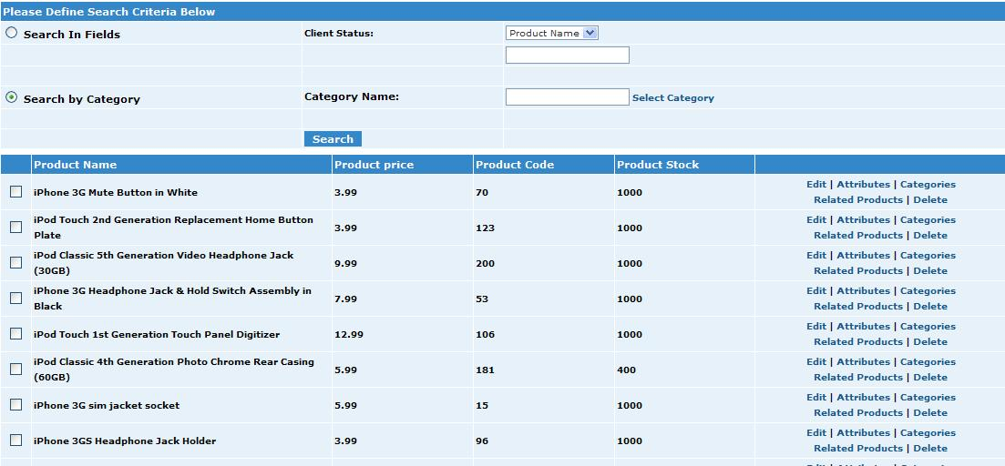

The product can be edited, deleted, add or remove attributes and related products can be assigned here by clicking the relative link in front of the product and specific products can be searched here by product name, product code or by category from the search criteria.

Edit Products
From the grid view that lists your products click the edit link next to the product you wish to edit. A popup page will appear, make the desired changes to the fields and click the update button to save your changes. Click the close button the popup page will be closed. For fields details see Section 1 Add Products.
Delete Products
From the grid view that lists your products, click the delete link next to the product you wish to delete. For deleting multiple products select the check boxes in front of the product you want to delete and click on the Delete Selected button at the bottom.
Add, Edit Attributes
From the grid view that lists your products click the attributes link next to the product you wish to edit or add attributes. The following popup will appear. Click on the update or delete links in front of the attribute to update or delete the attribute. To add more attributes to the product, click on the Add more link. Make sure that you write values for Price, weight and stock for each added attribute.

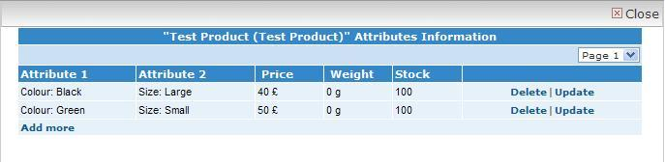

Assign, Unassign Categories
From the grid view that lists your products, click the Category link next to the product you wish to assign or unassign category. The following popup will appear. Select the category that you want to assign to the product and click Assign button. The category will be assigned to the product and will appear in the list showing the assigned categories to the product. To unassign the category select the checkbox in front of category and click Unassign button.

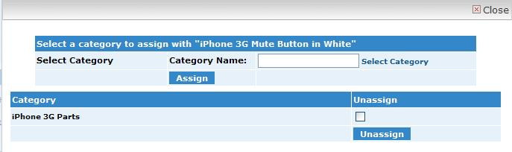

Assign, Unassign Related Products
From the grid view that lists your products click the Related Products link next to the product you wish to assign or unassign related products. The following popup will appear. To unassign a product select the check box in front of the product and click Unassign button. To assign a related product, first search the product either by entering the product name, code or search by selecting the category. The search result will appear as the last grid in the figure. Select the check box in front of the product and click Assign button. The product will be assigned as related product.



