Statistics Module

In this module you can view the statistics about from where the members hear about your website. Here is from where the client chooses the option on login page on client side.

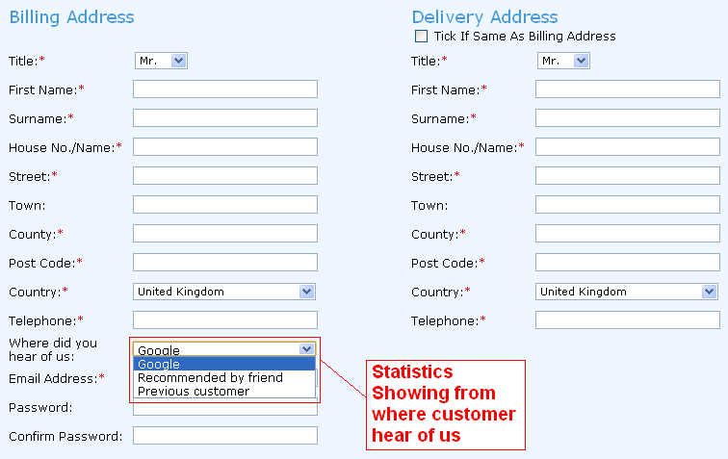

1. Show Statistics:
To view the statistics about from where the member hear about your website; click the Statistics button from the menu on left section of the admin area. It will expand the menu. Click on Show Statistics. The statistics will appear in grid view in the main area as following.

Members will select this option at the time of checkout.

Google – Shows the number of orders made by members who reached your website from google.

Recommended by friend – Shows the number of orders made by members who reached your website from recommended by friend.

Previous customer – Shows the number of orders made by members who are previous customers.

