Category Module

Before you add products to your shopping cart you need to add at least one category. Categories can be fully nested to any level desired (e.g. sub-categories, sub-sub-categories, etc.). Products can be mapped to more than one category, sub category, sub-sub-categories, etc. This is how the categories will look on client side.

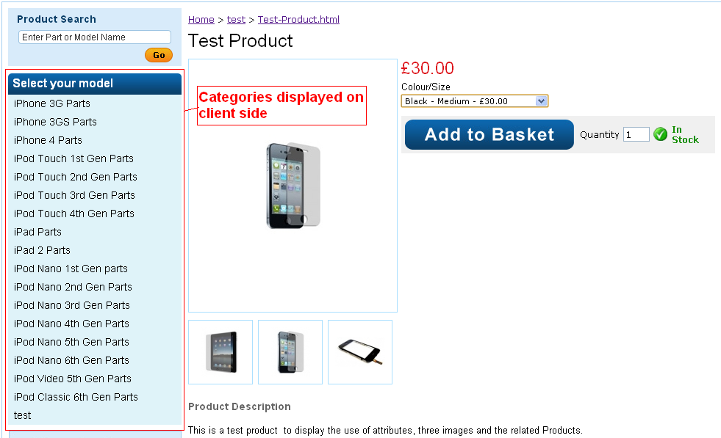

1. Add New Categories:
To add categories click the Category button form the menu on left section of the admin area. It will expand the menu, click on Add Category. Now in the main area click on the Main Category button the following form will appear.

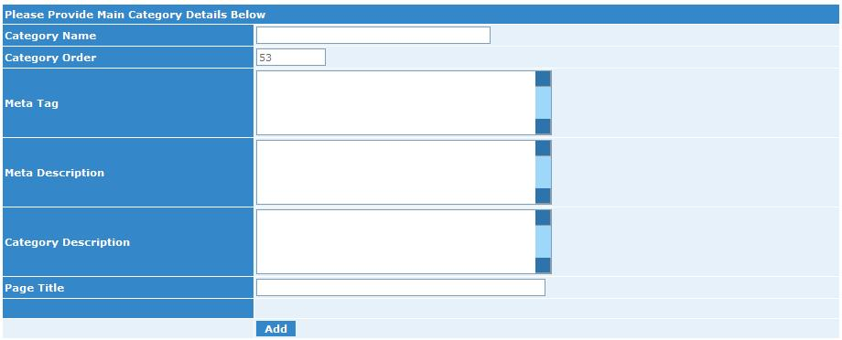

Category Name - Enter the product category that you wish to add in the “Category Name” field.

Category Order - The category order field controls the order in which the categories are displayed in the product catalog. Enter a numeric number from 1 to 999. The product categories will be sorted in ascending order by the category order field.

Meta Tag – The keywords entered in this field will be dynamically added in the URL of the product listing page when a user clicks on a category from the categories module. Enter keywords that are relevant and targeted towards your category. Targeted keywords in the URL help your SEO rankings.

Category Description - Category Description is displayed at the top of the product listing page when the category is clicked in the category menu. Read the admin module for detailed info about SEO and importance of Meta tag keyword and description.

Enter the information and click the add button the category will be added.

For adding sub category click on the Sub Category button a form will appear same as above with two extra fields.

Category Image – The category image uploaded here will be displayed to the user in the page showing the sub categories when on a main category is clicked.

Parent Category – The parent category is used to define subcategories and nested sub categories. If you choose a parent category from the dropdown list you are defining a subcategory or a sub sub category, etc.
.
Browse the image and select the parent category and click add the sub category will be added.
2. Manage Categories:
To edit or delete the existing categories click on the Manage Categories from the category menu the following page will appear.

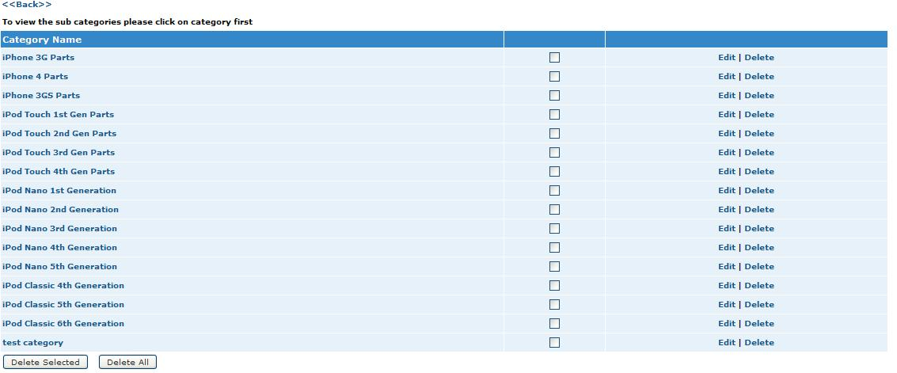

Edit Categories
From the grid view that lists your categories click the edit link next to the category you wish to edit. A popup page will make the desired changes to the fields and click the update button to save your changes. Click the close button the popup page will be closed.
Delete Categories
From the category grid that lists your categories click the delete link next to the category you wish to delete. To delete all the categories click on the Delete All button. For deleting multiple categories select the check boxes in front of the category you want to delete and click on the Delete Selected button in the bottom.

